**Covid-19: in numbers**

The story of a unique year, told through data. The charts here run direct from official sources. A live and interactive version of this dashboard is available here.

Richard Davies, Charlie Meyrick and Denes Csala

Starting in March 2020, Covid cases began to rise fast. The world began to grapple with the idea of exponential growth.

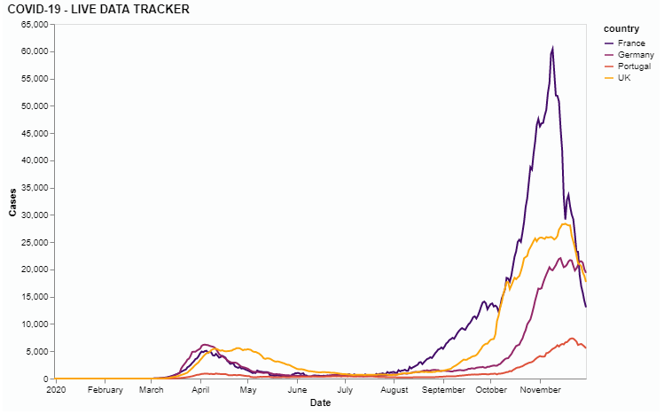

Covid-cases began to rise fast in the UK. The first lockdown was announced in [23rd March 2020]. People began to be admitted to hospital. The second and third waves were noticeable worse in Northern Ireland. The number of rose fast. The second wave deaths were lower, in part due to progress in medical treatment.

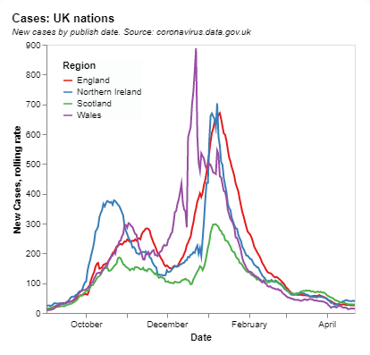 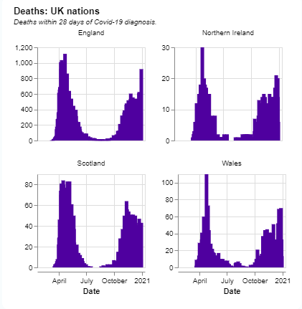 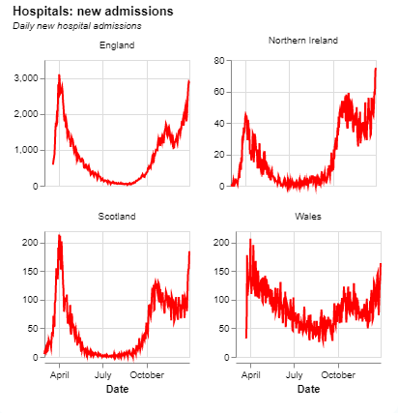

With the pandemic set in, it because clear this was an unequal virus. The elderly, men, BAME communities and those in exposed occupations have been most at risk.

[CHARTS BY OCCUPATION, AGE, GENDER, ETHICITY]

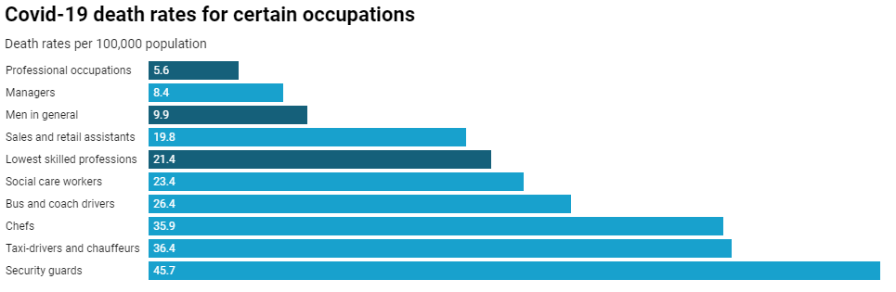

<https://www.menshealthforum.org.uk/covid-19-statistics-england-wales>

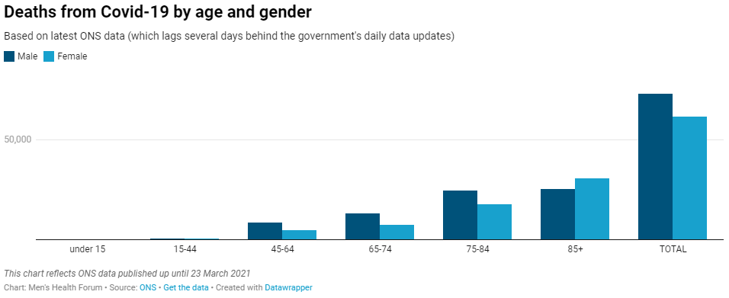

As government responses around the world kicked in two things were paramount: to find out who had the disease, via testing, and to find a vaccination. By mid-summer tests were running at X per day in the UK. In 2021 there have been X days on which over 1m tests were conducted.

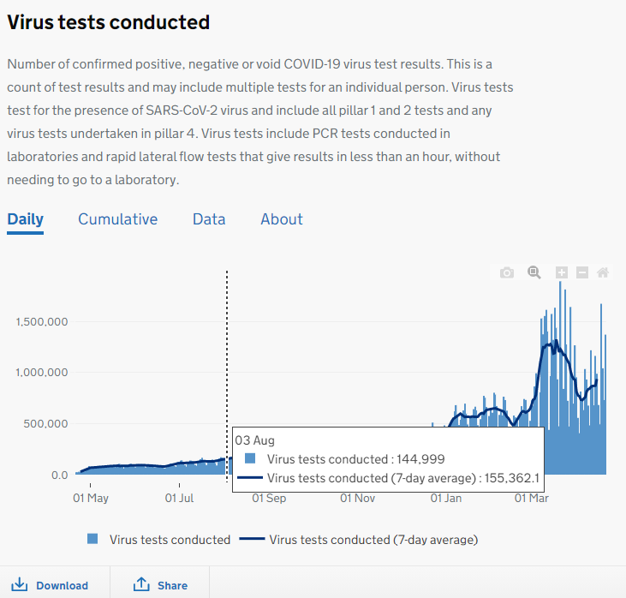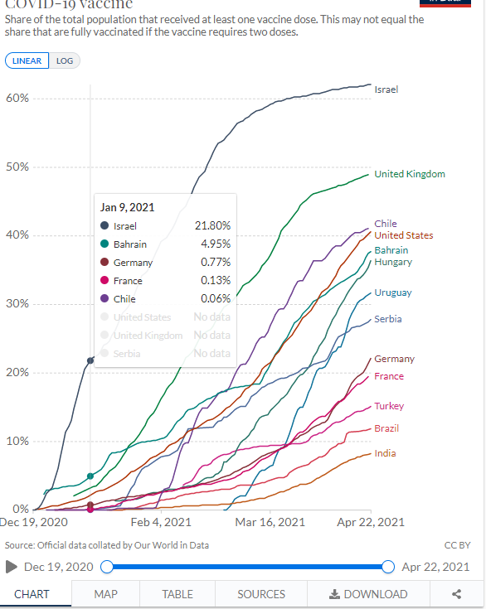

Vaccines were discovered on DATE and were available by DATA. Having been later than many countries to roll out its testing, the UK has led the world in the speed of its vaccine program.